**NANDHA ENGINEERING COLLEGE**

**(AutonomousInstitution)**

Erode-638 052



**TABLEAU-TWO CREDIT COURSE**

**IV–Semester**

**B.Tech-Artificial IntelligenceandDataScience**

**NAME :M.N.SAMYUKTHA**

**BRANCH :B.TECH AI & DS**

**YEAR : II**

**TABLEAU**

Tableau is primarily used for [data visualization](https://builtin.com/learn/tech-dictionary/data-visualization) and [business intelligence](https://builtin.com/learn/tech-dictionary/business-intelligence) as a way of sharing and analyzing information.

Tableau is a suite of products comprised of desktop, public, online, server and reader tools that streamline the visualization and sharing of data. The software is capable of connecting and extracting data from every data storage platform available, and the tools that make up Tableau can essentially be broken into two subfields: [developer](https://builtin.com/learn/careers/front-end-developer) tools and sharing tools.

Developer tools are used to create [dashboards, charts, reports and other visualization methods](https://builtin.com/data-science/dataviz-color-tableau) so that data imported into Tableau can be organized, manipulated and displayed in a way that relates it to other data. These tools help users [answer questions](https://builtin.com/data-science/data-visualization-lessons-pandemic) with data, discover trends and form hypotheses about business performance. Tableau’s desktop and public products fall into this category.

Sharing tools are the tools within Tableau that are responsible for sharing visualizations like reports and dashboards with others inside and outside of the organization. Data visualizations can be exported in a variety of ways and can be accessed by users via desktop, mobile or email once the visualization has been moved from Tableau Desktop to Tableau Server.

**APPLICATION**

The Tableau data visualization tool makes manufacturing businesses fulfill the demand of modern customers with data-driven decisions. If you know what is Tableau, you will understand that it offers operational insights to manufacturing businesses. The valuable insights can be used by manufacturers for the following:

* Enhanced agility of the supply chain
* Real-time insights regarding how manufacturing businesses operate on a macro and micro scale
* Use of predictive analysis for smart decisions
* Performing market analysis
* Detecting and eliminating bottlenecks in the supply chain

**SUPERSTORE SALES REPORT**

## **Objective**

The goal of this project is to **analyze and visualize** key business metrics from the **Superstore dataset** using Tableau. The dashboard enables dynamic and intuitive insights into sales performance, product demand, and regional trends, helping stakeholders make **data-driven decisions**.

### **1. Dataset Understanding**

* **Dataset Used**: Sample - Superstore.xls
* **Key Fields Identified**:
  + Product Category and Sub-Category
  + Sales and Profit
  + Quantity Sold
  + Region and State
  + Customer Segment
  + Shipping Date and Order Date

### 2.**Data Preparation**

* Removed missing and irrelevant data points.
* Grouped data into categories and sub-categories.
* Standardized column names for easy visualization.
* Aggregated sales, quantity, and profit metrics.

### 3**.Key Insights & Analysis**

* **Top Performing Sub-Category**: Machines generated the highest sales.
* **High Quantity but Lower Sales**: Accessories and Supplies sold in large quantities but generated lower revenue.
* **Regional Trends**: Certain states like California and New York dominated sales.
* **Category Performance**:
  + Technology leads in total sales.
  + Office Supplies and Furniture have moderate sales but high volume movement.

### 4.**Advanced Features Suggested**

* **Trendlines**: Could be added to sales over time (not present yet).
* **Forecasting**: Future sales predictions can be incorporated based on historical data.
* **Calculated Fields**: Example: Profit Margin = Profit / Sales.
* **Interactivity**: Filters by region, category, customer segment for deeper drill-down.

### 5.**Aesthetic Design**

* **Color Theme**: Dark background with pastel color highlights.
* **Chart Labeling**: Clear labels and legends.
* **Navigation**: Logical flow from high-level overview (category) to detailed breakdown (sub-category and region).

### **Dashboard Components**

| **Chart** | **Description** |
| --- | --- |
| **Sales vs Sub-Category (Bar Chart)** | Visualizes which sub-categories generate the most revenue. |
| **Quantity vs Sub-Category (Pie Chart)** | Highlights the volume of products sold across different sub-categories. |
| **Category vs Sales (Treemap)** | Displays high-level sales contribution by major product categories (Furniture, Technology, Office Supplies). |
| **Quantity vs Sales (Bar Chart)** | Analyzes the relationship between quantity sold and total sales for sub-categories. |
| **Map Chart** | Geographic visualization of sales distribution across U.S. states. |

# **Real-World Use**

* Sales managers can prioritize high-selling products.
* Marketing teams can target underperforming regions.
* Inventory teams can forecast future product demands.

### **BAR CHART( SUB-CATEGORY VS SALES)**

**OBJECTIVE**

The aim of this bar chart is to visualize the sales performance of various sub-categories within three primary product categories—Furniture, Office Supplies, and Technology. This chart provides stakeholders with clear insights into the sales distribution across sub-categories, assisting in strategic decision-making and identifying high-impact areas.

**Steps to Execute the Chart Creation**

1. **Understand the Dataset**
   * Analyze attributes like sub-category names, sales figures, and categories (Furniture, Office Supplies, Technology).
   * Define the key metric: total sales revenue per sub-category.
2. **Define the Chart Element**
   * **Bar Chart**: Ideal for comparing sales data visually across multiple sub-categories.
   * Use color coding to differentiate categories for quick interpretation.
3. **Data Preparation**
   * Clean data by ensuring accuracy in the sub-category and sales fields.
   * Group data by sub-category and aggregate total sales figures for visualization.
4. **Build the Chart in Tableau**
   * Import the processed data into Tableau.
   * Select "Bar Chart" as the visualization type.
   * Drag Sub-Category to the "Rows" field and Sales to the "Columns" field.
   * Use color coding to represent categories (Furniture, Office Supplies, Technology).
   * Add a legend explaining the colors to improve accessibility and understanding.
5. **Design the Chart for Usability**
   * Ensure horizontal bars for ease of reading sub-category names.
   * Arrange bars from highest to lowest sales for quick comparison.
   * Use a slider control, like "Parameter 1", to add interactivity and filter results dynamically.
6. **Insights and Analysis**
   * Sub-categories like Machines (133,241 sales) and Copiers (85,409 sales) dominate the chart, signaling high revenue contributors.
   * Mid-performing sub-categories such as Binders, Phones, and Chairs show balanced contributions, worth exploring further for scaling opportunities.
   * Low-performing sub-categories like Art (625 sales) and Envelopes (558 sales) highlight potential areas for improvement or reconsideration in inventory or marketing efforts.

**Real-World Applications**

* **Resource Allocation**: Focus on boosting inventory and marketing for high-performing sub-categories like Machines and Copiers.
* **Strategic Planning**: Identify sub-categories that need improvement, such as Art and Envelopes, to implement targeted promotional efforts.
* **Performance Insights**: Monitor the proportional contribution of categories (Furniture, Office Supplies, Technology) to optimize long-term business strategies.

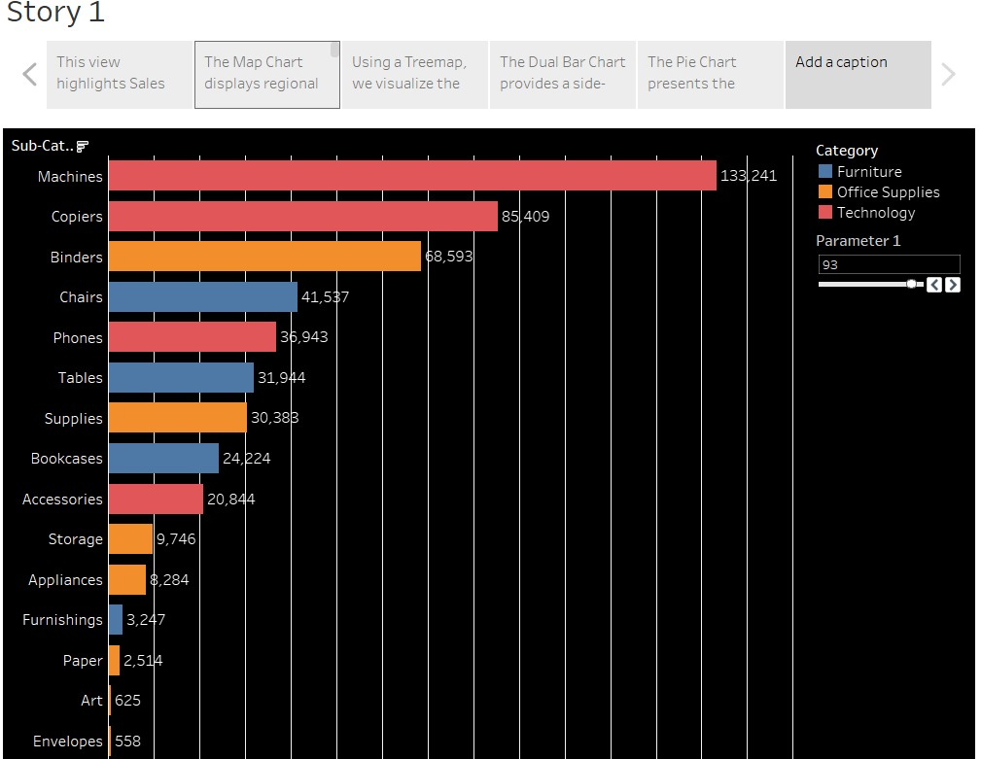

**TREE MAP (CATEGORY VS SALES)**

**OBJECTIVE**

This treemap chart is designed to provide a visual breakdown of sales performance across three main categories: Technology, Furniture, and Office Supplies. The chart allows stakeholders to quickly identify the dominant category in terms of sales and compare the contribution of each category to the overall sales.

**Steps to Execute the Chart Creation**

1. **Understand the Dataset**
   * Analyze attributes such as categories (Technology, Furniture, Office Supplies) and their respective sales figures.
   * Define the key metric for this chart: total sales for each category.
2. **Define the Chart Element**
   * **Treemap Chart**: This visualization displays categories as rectangles, with the size of each rectangle proportional to the sales volume of the category.
   * Use labels within the rectangles to display category names and sales values for clarity.
3. **Data Preparation**
   * Clean and preprocess the dataset to ensure accurate sales figures for each category.
   * Aggregate total sales for each category before importing the data into Tableau.
4. **Build the Chart in Tableau**
   * Import the cleaned dataset into Tableau.
   * Select "Treemap Chart" as the visualization type.
   * Drag Category to the "Details" field and Sales to the "Size" field.
   * Use color coding to differentiate categories and improve visual appeal.
5. **Design the Chart for Usability**
   * Ensure that rectangles are sized and labeled appropriately to highlight sales disparities.
   * Use a consistent color palette for better accessibility.
   * Add a legend or labels for clear interpretation.
6. **Insights and Analysis**
   * The **Technology** category dominates sales, with a total value of **836,154**, reflecting its strong performance.
   * The **Furniture** and **Office Supplies** categories show smaller rectangles, indicating comparatively lower sales volumes.
   * This distribution suggests a potential focus area for increasing sales in the Furniture and Office Supplies categories.

**Enhancements**

* **Trend Analysis**: Pair this chart with a line chart to analyze how category sales change over time.
* **Forecasting**: Use Tableau’s forecasting tools to predict future sales growth for each category.
* **Calculated Fields**: Create metrics like sales percentage contribution per category to understand their proportional impact more effectively.

**Real-World Applications**

* **Resource Allocation**: Focus resources on the **Technology** category to sustain its high performance while exploring strategies to boost Furniture and Office Supplies sales.
* **Strategic Planning**: Identify categories with lower sales to develop targeted promotional campaigns or product improvements.
* **Performance Monitoring**: Use this chart to track shifts in category performance over different time periods.

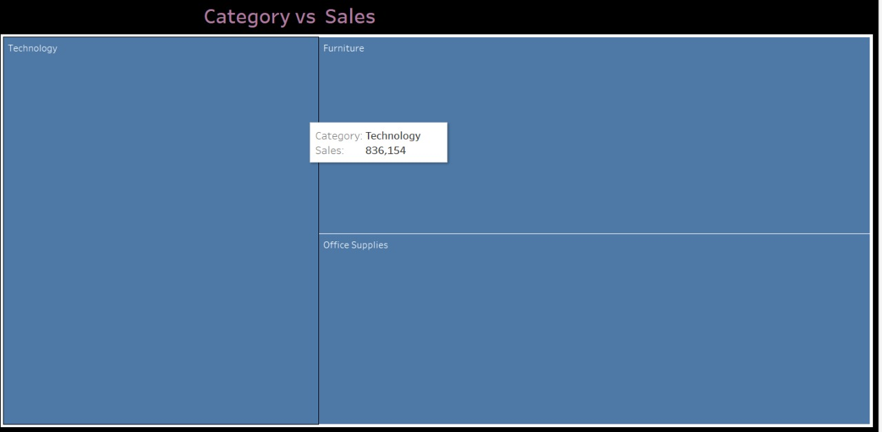

**BUTTERFLY CHART(QUANTITY VS SALES)**

**OBJECTIVE**

The goal of this bar chart is to analyze and compare the quantity of products sold against the sales revenue generated for various sub-categories. This chart helps identify correlations between quantity sold and revenue, aiding stakeholders in strategic decision-making and performance evaluation.

**Steps to Execute the Chart Creation**

1. **Understand the Dataset**
   * Explore attributes such as sub-category names, quantity sold, and sales figures.
   * Define two key metrics: Quantity (number of products sold) and Sales (revenue generated).
2. **Define the Chart Element**
   * **Bar Chart**: This chart uses horizontal bars to visualize the relationship between quantity and sales for each sub-category.
   * Each sub-category has two bars:
     + One representing **quantity**.
     + One representing **sales**.
3. **Data Preparation**
   * Clean and preprocess the dataset to ensure accuracy in the quantity and sales fields.
   * Aggregate data by sub-category to simplify visualization.
4. **Build the Chart in Tableau**
   * Import the cleaned dataset into Tableau.
   * Drag Sub-Category to the "Rows" field and both Quantity and Sales to the "Columns" field.
   * Differentiate the bars by color to represent quantity (e.g., orange, blue, red) and sales (gray).
   * Add horizontal axes at the bottom for quantity (0–6000) and at the top for sales (0–300,000).
5. **Design the Chart for Usability**
   * Ensure each sub-category is clearly labeled.
   * Arrange bars logically for quick comparisons.
   * Provide color-coded legends for easy interpretation of quantity vs sales.
6. **Insights and Analysis**
   * **High Quantity and Sales**: Binders and Paper show strong performance, with high quantity (5,974 and 5,178 respectively) and substantial sales revenue.
   * **Disparity Between Metrics**: Some sub-categories like Machines have low quantities but high sales revenue (suggesting high-value items).
   * **Low Quantity and Sales**: Sub-categories like Art and Envelopes demonstrate underperformance, offering opportunities for targeted strategies.

**Trend Analysis** This chart does not inherently show trends, but when combined with time-series data, it can highlight shifts in quantity and sales performance over time.

**Real-World Applications**

* **Inventory Decisions**: Focus on stocking high-quantity sub-categories like Binders and Paper.
* **Performance Evaluation**: Analyze low-performing sub-categories like Art and Envelopes to improve marketing or product design.
* **Profitability Analysis**: Investigate sub-categories like Machines that generate high sales with lower quantities.

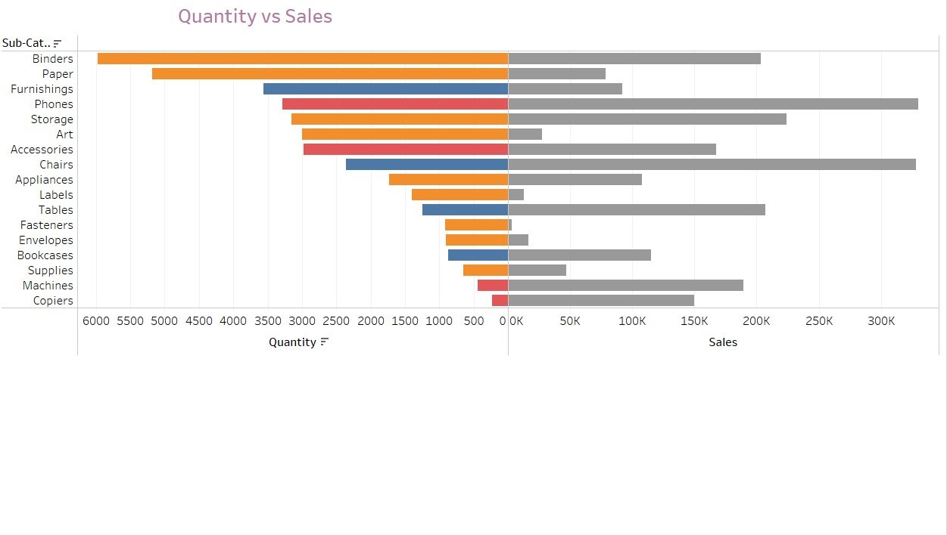

**PIE CHART (QUANTITY V SUBCATEGORY)**

**OBJECTIVE**

The purpose of this pie chart is to visualize the distribution of quantities sold across various product subcategories. It provides a clear, proportional representation that helps identify high-performing and low-performing subcategories based on quantity.

**Steps to Execute the Chart Creation**

1. **Understand the Dataset**
   * Identify key attributes such as sub-category names and their respective quantities sold.
   * Define the metric of interest: quantity sold across subcategories.
2. **Define the Chart Element**
   * **Pie Chart**: Selected for its ability to represent proportional distribution effectively.
   * Each segment corresponds to a sub-category, with its size proportional to the quantity.
3. **Data Preparation**
   * Clean and preprocess the dataset to ensure accuracy in the quantity and sub-category fields.
   * Aggregate quantities by sub-category for concise visualization.
4. **Build the Chart in Tableau**
   * Import the cleaned dataset into Tableau.
   * Drag Sub-Category to the "Slices" field and Quantity to the "Values" field.
   * Assign colors to slices to differentiate subcategories clearly.
5. **Design the Chart for Usability**
   * Label each segment with the sub-category name and quantity value.
   * Use a legend to explain the color coding for accessibility.
   * Ensure proportional representation by adjusting the size of slices dynamically.
6. **Insights and Analysis**
   * **High Quantities**: Sub-categories such as Binders (5,974) and Paper (5,178) dominate, indicating strong market demand.
   * **Moderate Quantities**: Sub-categories like Furnishings (3,563), Phones (3,289), and Art (3,000) contribute significantly but don’t lead.
   * **Low Quantities**: Sub-categories such as Machines (440) and Supplies (647) exhibit minimal distribution, reflecting potential niche markets or low demand.

**Enhancements**

* **Trend Analysis**: Incorporate a time-series chart to visualize changes in quantities sold for each sub-category over time.
* **Forecasting**: Utilize Tableau’s forecasting tools to predict future demand for high-performing subcategories.
* **Calculated Fields**: Create metrics such as percentage contribution for each sub-category to the overall quantity.

**Real-World Applications**

* **Inventory Management**: Focus on stocking high-demand subcategories like Binders and Paper.
* **Performance Evaluation**: Evaluate low-performing subcategories, like Machines and Supplies, to explore improvement strategies.
* **Resource Allocation**: Adjust procurement and marketing efforts based on proportional contributions of subcategories to total quantity.

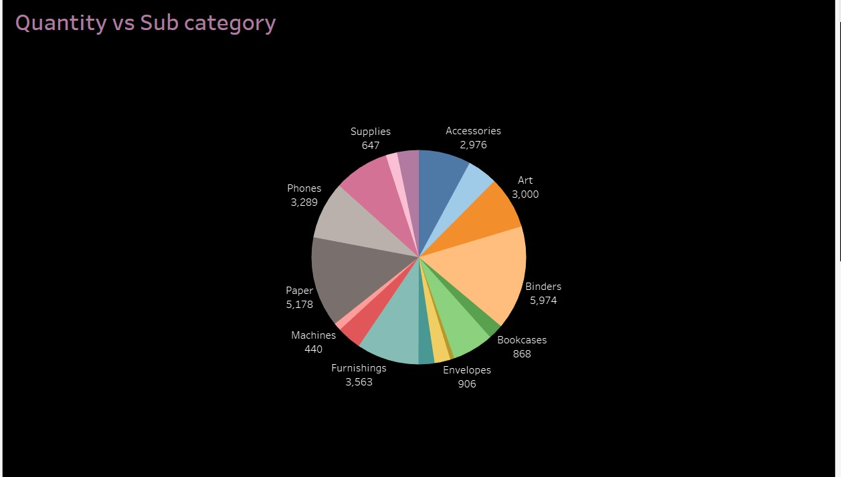

**MAP CHART (SALES VS COUNTRY)**

**OBJECTIVE**

The purpose of this pie chart is to visualize the distribution of quantities sold across various product subcategories. It provides a clear, proportional representation that helps identify high-performing and low-performing subcategories based on quantity.

**Steps to Execute the Chart Creation**

1. **Understand the Dataset**
   * Identify key attributes such as sub-category names and their respective quantities sold.
   * Define the metric of interest: quantity sold across subcategories.
2. **Define the Chart Element**
   * **Pie Chart**: Selected for its ability to represent proportional distribution effectively.
   * Each segment corresponds to a sub-category, with its size proportional to the quantity.
3. **Data Preparation**
   * Clean and preprocess the dataset to ensure accuracy in the quantity and sub-category fields.
   * Aggregate quantities by sub-category for concise visualization.
4. **Build the Chart in Tableau**
   * Import the cleaned dataset into Tableau.
   * Drag Sub-Category to the "Slices" field and Quantity to the "Values" field.
   * Assign colors to slices to differentiate subcategories clearly.
5. **Design the Chart for Usability**
   * Label each segment with the sub-category name and quantity value.
   * Use a legend to explain the color coding for accessibility.
   * Ensure proportional representation by adjusting the size of slices dynamically.
6. **Insights and Analysis**
   * **High Quantities**: Sub-categories such as Binders (5,974) and Paper (5,178) dominate, indicating strong market demand.
   * **Moderate Quantities**: Sub-categories like Furnishings (3,563), Phones (3,289), and Art (3,000) contribute significantly but don’t lead.
   * **Low Quantities**: Sub-categories such as Machines (440) and Supplies (647) exhibit minimal distribution, reflecting potential niche markets or low demand.

**Enhancements**

* **Trend Analysis**: Incorporate a time-series chart to visualize changes in quantities sold for each sub-category over time.
* **Forecasting**: Utilize Tableau’s forecasting tools to predict future demand for high-performing subcategories.
* **Calculated Fields**: Create metrics such as percentage contribution for each sub-category to the overall quantity.

**Real-World Applications**

* **Inventory Management**: Focus on stocking high-demand subcategories like Binders and Paper.
* **Performance Evaluation**: Evaluate low-performing subcategories, like Machines and Supplies, to explore improvement strategies.
* **Resource Allocation**: Adjust procurement and marketing efforts based on proportional contributions of subcategories to total quantity.

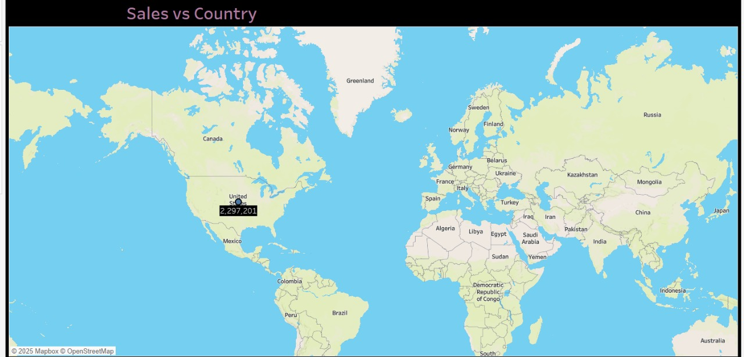

**SUPERSTORE SALES REPORT DASHBOARD.**

**DASHBOARD1:**

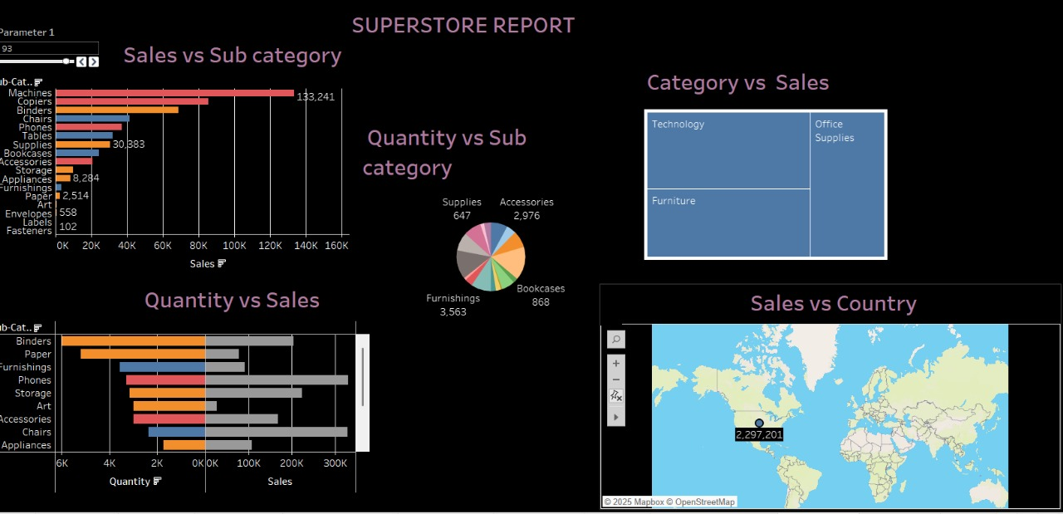

**DASHBOARD 2:**

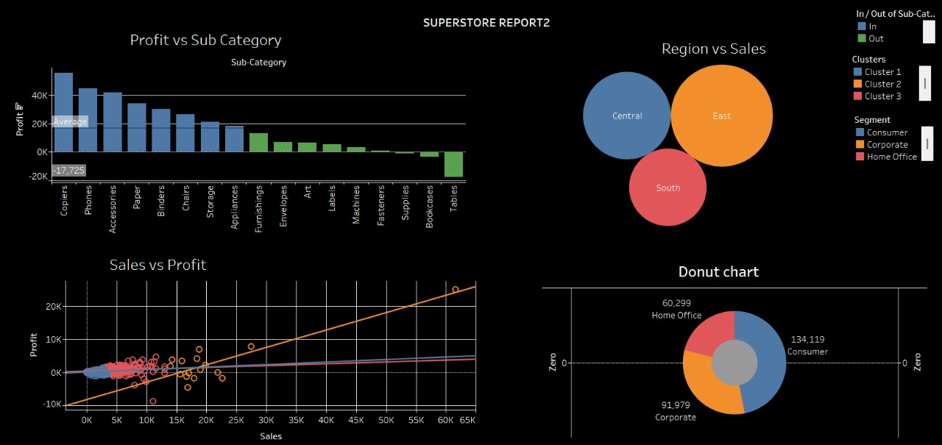

**Project Overview**

This project revolves around the creation of a comprehensive Tableau dashboard titled **"SUPERSTORE REPORT"**. The primary objective is to provide actionable insights into the sales data of a superstore by utilizing diverse and interactive visualizations. The dashboard incorporates a variety of chart types, such as bar charts, pie charts, treemaps, and maps, to analyze sales performance across categories, subcategories, and geographical regions. By enabling stakeholders to compare and interpret data intuitively, the dashboard facilitates data-driven decision-making and trend analysis.

**Key Features of the Dashboard**

1. **Sales vs Sub-Category (Bar Chart)**: Highlights the sales performance of individual subcategories, identifying top and underperformers like Machines and Fasteners.
2. **Quantity vs Sub-Category (Pie Chart)**: Visualizes the proportional distribution of quantities sold across different subcategories to understand demand patterns.
3. **Category vs Sales (Treemap Chart)**: Provides a visual representation of sales distribution across the primary categories (Furniture, Office Supplies, Technology).
4. **Quantity vs Sales (Bar Chart)**: Compares the number of units sold to sales revenue across subcategories, identifying correlations and gaps.
5. **Sales vs Country (Map)**: Depicts sales data geographically, highlighting areas of high revenue generation.

**Insights Gained**

* **Top Performers**: Subcategories like Machines, Copiers, and Binders demonstrate strong sales figures, reflecting high demand.
* **Low Performers**: Subcategories like Fasteners and Envelopes indicate minimal sales, suggesting opportunities for improvement or repositioning.
* **Category Contribution**: The **Technology** category leads in overall sales, emphasizing its importance to the business.
* **Regional Analysis**: Geographical data allows stakeholders to identify key markets contributing to revenue

**CONCLUSION:**

**T**he "SUPERSTORE REPORT" Tableau dashboard successfully achieves its goal of visualizing critical sales metrics in an interactive and intuitive manner. By leveraging diverse chart types, the dashboard not only uncovers meaningful patterns but also empowers stakeholders to make informed decisions. The insights gained from this project can guide inventory management, marketing strategies, and operational planning, ensuring continued business growth and customer satisfaction.

The implementation of **actions** allows users to interact with the dashboard seamlessly, such as drilling down into specific categories or filtering data by regions. **Parameters** provide flexibility, enabling users to adjust metrics dynamically, such as selecting specific date ranges, categories, or custom thresholds for analysis. Leveraging **advanced techniques** has allowed the creation of calculated fields, trendlines, and forecasting models, providing predictive insights and deeper context to the visualized data.

By combining these features, the "SUPERSTORE REPORT" dashboard not only identifies trends and correlations but also empowers stakeholders with the tools to make agile, data-driven decisions. This innovative approach ensures the dashboard remains a valuable resource for strategic planning, inventory management, and performance evaluation, driving the superstore's success in competitive markets.

**THANK**

**YOU……!!!**